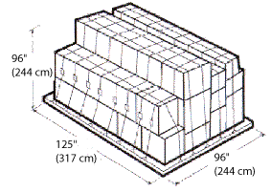
AIR FREIGHT CONTAINER DIMENSIONS

Main Deck Pallet (Equivalent to IATA Type 2) External Displacement:
606 cu ft/17.16 cu m Maximum Gross Weight: 15,000 lb/6,804 kg
Maximum External Dimensions: (L x W x H) Contoured
125" x 96" x 96"
317cm x 244cm x 244cm

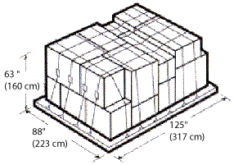

LD-7
(Equivalent to IATA Type 5) External Displacement:
379.9 cu ft/10 cu m Maximum Gross Weight: 10,200 lb/4,627 kg
Maximum External Dimensions: (L x W x H) Contoured
125" x 88" x 63"
317 cm x 223 cm x 160 cm

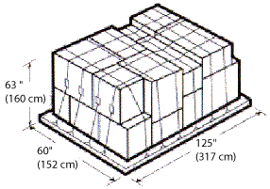

P9A Lower Deck Pallet (Equivalent to IATA Type 6) External Displacement:
242 cu ft/6.9 cu m Maximum Gross Weight: 7,000 lb/3,175 kg
Maximum External Dimensions: (L x W x H) Contoured
125" x 60" x 63"
317 cm x 152 cm x 160 cm

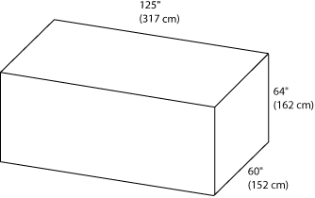

LD-11
(Equivalent to IATA Type 6) Internal Capacity:
242 cu ft/6.9 cu m Maximum Gross Weight: 7,000 lbs/3,176 kg
Maximum External Dimensions: (L x W x H) Contoured
125" x 60" x 64"
317 cm x 152 cm x 162 cm

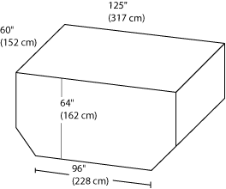

LD-8
(Equivalent to IATA Type 6A) Internal Capacity:
243 cu ft/6.9 cu m Maximum Gross Weight: 5,400 lb/2,450 kg
Maximum External Dimensions: (L x W x H) Contoured
96" x 60" x 64"
228 cm x 152 cm x 162 cm

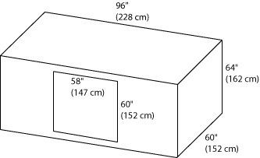

LD-4
(Equivalent to IATA Type 7A) Internal Capacity:
174 cu ft/5 cu m Maximum Gross Weight: 5,400 lb/2,450 kg
Maximum External Dimensions: (L x W x H) Contoured
96" x 60" x 64"
228 cm x 152 cm x 162 cm

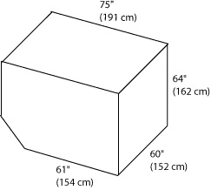

LD-3
(Equivalent to IATA Type 8) Internal Capacity:
150 cu ft/4 cu m Maximum Gross Weight: 3,500 lb/1,588 kg
Maximum External Dimensions: (L x W x H) Contoured
61" x 60" x 64"
154 cm x 152 cm x 162 cm

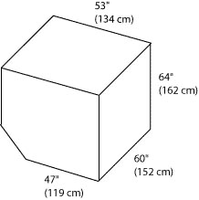

LD-2
(Equivalent to IATA Type 8D) Internal Capacity:
120 cu ft/3 cu m Maximum Gross Weight: 2,700 lb/1,225 kg
Maximum External Dimensions: (L x W x H) Contoured
47" x 60" x 64"
119 cm x 152 cm x 162 cm

